Ben Nevis 1344
Snowdon 1085
Scafell Pike 978

Situated in the Highlands region of Scotland, Ben Nevis is the highest peak in Britain. The coastal town of Fort William is at the foot of the Ben, and has many outdoor sports and climbing shops, good accommodation and places to eat. It is popular with tourists in the summer, and with skiers and winter climbers during the winter, so arrange somewhere to stay well before you arrive.
The Youth Hostel and start of the Tourist Path are only two minutes drive from the center of the town and the railway station.

The 'Mountain Track' Route.
From the car park at Glen Nevis Visitor Center, cross the footbridge and walk beside the river a short while, then left beside a wall up to the start of the main path. Climb steadily and soon the path from Glen Nevis Youth Hostel joins from the right. Continue upward, crossing two Alpine style footbridges, then more steeply to Lochan Meall an t-Siudhe, where a second path joins. Please note any erosion diversions in force around this area.
Bear right at the junction and head up the zig-zagging trail. After the zig-zags, the path eases onto the summit plateau, which should be treated with caution, especially in poor visibiliy.
Walking times
As a rough guide, you should be aiming to achieve
these times at least on the mountain
From the Visitor Centre:
2.5 - 3 hours climb,
2 - 2.5 hours descent.
Remember that as Fort William is at sea level, you will have to climb almost the full 1344m to the top. The start to Scafell and Snowdon both allow you to gain some height in your vehicle first. This is one good reason to start your challenge in Scotland rather than Wales !!
The path to the top is steep or very steep for it's entire length, but is well maintained. Good navigational skills are required for the summit in poor visibility.

Image produced from the Ordnance Survey Get-a-map service. Image reproduced with 'kind' (?) permission of Ordnance Survey and Multi Media Mapping.
Fort William :
You will find a number of good outdoor equipment and ski shops to browse, as well as some good seafood restaurants and chip shops. Fort William has a Youth Hostel, a Morrisons store with petrol station, and a McDonnalds. So you will be able to get provisions, juice up the motor, and fill the flasks with coffee before your drive to Cumbria.

Mobile phone coverage
The nearest emergency phone is outside the Youth Hostel at Glen Nevis.
We found Orange coverage to be poor to moderate between the Ben and the car park.
The original path (now named the 'Mountain Track') was constructed in the 1880's to service the observatory which was being built on the summit plateau. This is now no more than a badly derelict building, however the path remains. The path on the summit plateau is not distinct, and should be treated with upmost care in poor visibility. Large cornices will sometimes remain well into the summer months, disguising the top of many gullies. Footprints onto the cornices are from climbers.
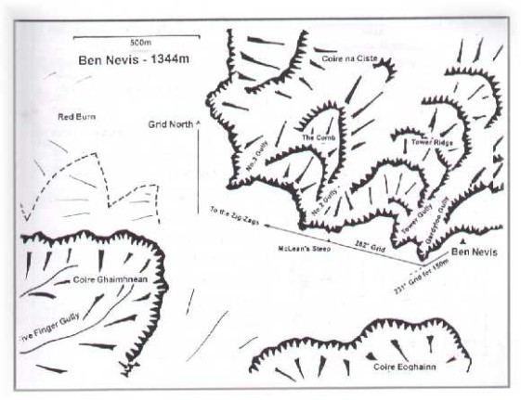
Ben Nevis Summit Area Map
Descending from the summit.
This advice comes from Lochaber Mountain Rescue Team, and is printed on the summit area map which they produce.
Warning : these bearings and distances are only likely to be of any assistance if you are already a competent navigator. Even very experienced mountaineers can have great difficulty navigating accurately in severe wind or white-out conditions, such as occur frequently on the Ben Nevis plateau.
1. From the summit trig. pillar walk 150m on a grid bearing of 231` to near the top of Gardyloo Gully (first marker pole*).
2. Then follow the grid bearing of 282` to clear the plateau (a second marker pole is situated 300m along this second bearing, at the top of McLean's Steep*).
Marker poles are removed regularly by people who disagree with their placement, so do not count on them being in situ
Walking on BEN NEVIS information leaflet/webpage from the Mountaineering Council of Scotland. Lots of good information - take a look.
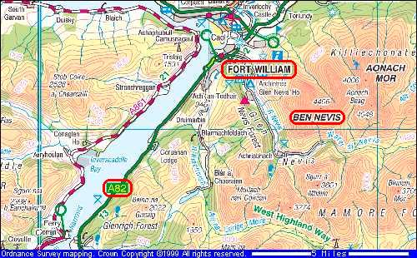

Scafell Pike ma surprise walkers with its rocky and rugged paths, becoming very steep and unrelenting towards the top. Lower paths are well defined and gentle, but don't be fooled into relaxing your navigation! The Pike is very often covered by mist and many Three Peakers may face at least some part of this mountain in darkness. The rocky plateau around the top can disorientate weary and tired walkers. Extra care should be taken underfoot when descending to save ankle and knee problems. Walking poles may be useful for anyone who suffers with leg problems on steep, rough descents.

Scafell Pike is located in the western area of the Lake District National Park and is mostly owned by the National Trust. During the summer months, Scafell massif and the surrounding area becomes very busy with visitors, many car parks and facilities becoming full to capacity. Access roads into the area are small, mostly single track, and can quickly become congested. Scafell Pike Training Days 19/20 April 2008
Take care on the narrow, twisty roads..!
Take this into account when planning dates for your challenge.
There are two main approaches for three peaks challenges,
from Seathwaite, or via Wasdale Head.
Route from Seathwaite: From parking in the lane, quietly go through the farm and follow the main path easily to Stockley Bridge. Cross the bridge and continue along the path into Styhead Gill, more steeply now. From the mountain rescue kit at Sty Head, bear left then turn right onto the Corridor Route, through the crags to Lingmell Col. Bear left here for the final climb to the top.

Route from Wasdale: From the car park at Wasdale Head, head south on the tarmac road to the style/gate and bridleway and footpath signs. Follow the footpath through a field to cross a river on the footbridge. Gentle uphill path right, to path junction at Lingmell Gill. Left uphill, through gate and continue uphill by the gill. Cross river and climb more steeply past Brown Tongue.
Bear left on the main path here.
The route via Mickledore is subject to serious
errosion and should be avoided for this challenge.
At Lingmell Col bear right for the final climb to the summit
Walking times
As a rough guide, you should be aiming to achieve
these times at least on the mountain
From Wasdale : 2.5 hours climb, 1.5 hour descent.
From Seathwaite : 3 hours climb, 2 hours descent.
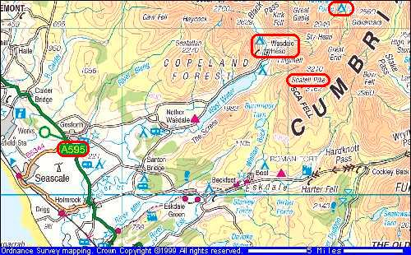

Snowdon is normally the final mountain to be tackled by most teams, and although not a difficult mountain in itself, you may well find this the most challenging due to fatigue and parhaps an unexpectedly long and steep descent into Llanberis. Currently the summit cafe and station do not exist, although the new £8.3m cafe (Hafod Eryri) is due to open late 2008, so do not expect to get a cold beer at the summit - or a train down..!
It's well worth checking out the construction progress before your challenge on the Snowdon Summit Blog. The actual summit cairn is only a few metres from the pictured construction area.
Recommended Approach Route.
Starting at Pen-Y-Pass allows the greatest height gain in your vehicle, and the smallest amount of climbing needed by walkers. However, the Pay & Display car park at Pen-Y-Pass fills up very quickly, and during a sunny weekend is often full by 9am. If you arrive between 9am and 3pm, you should expect to only be able to drop off walkers here. On very busy periods, even a simple drop off may not be possible, and the turning/drop off area may be closed to all vehicles apart from local shuttle buses.
Vehicles parked on the road will be given parking tickets, or possibly removed, and a local land owner has blocked areas previously used for parking, leading to more congestion problems.
Please consider our recommended approach route: Leave A55 by last exit before Bangor, onto A5 for just 100 metres. Llanberis and 'Electric Mountain' are well signposted. At mini roundabout, turn right onto A4244 and pass 24 hour petrol station on your right (older maps show this as a 'B' road). After 4 miles, at next roundabout, turn left still on A4244. Follow for another 4 miles to junction with A4086. Turn left, drive through Llanberis until Nant Peris - stop at the free car park on your right.
Here, all walkers should sort out their equipment, put on boots and waterproofs, etc., get rucksack and walking poles to hand, and be ready to start their next walk. They must be ready to literally get out of the vehicle and start walking..! Pen-Y-Pass is only 10 minutes away.
At Pen-Y-Pass, pull into turning area, let your team get out, then return down the Llanberis Pass to park up in Llanberis. Your team should walk down the Llanberis Path to meet up with you.
Snowdon (1085m)

The Walking Route.
Two routes to the summit are possible - the Pyg Track or the Miners Path. Previously we have recommended the Pyg Track, but in recent years the Miners Path has been hugely improved and we now recommend this path as the most suitable for Three Peaks Challenge teams.
The Pyg Track is well used and can be very popular throughout the year, it also serves as one route to the base of Crib Goch and is used by scramblers and climbers, as well as walkers. Take great care not to divert from the path towards Crib Goch itself. Starting from the car park at Pen-y-pass, it climbs steadily to meet the summit ridge, then just a short walk to the top, and station cafe.
The Miners Track is a wide, well maintained path, which leads quite gently around the lower reservoir of Llyn Llydaw, crossing the causeway, then climbing to the northern tip of Glaslyn, where the real climb begins. Climb the steep zig-zags and meet the Pyg Track, before joining the route from Llanberis at a rock post. Then just a short walk to the summit.
The descent should be via the Llanberis path, a fairly well maintained and popular route, generally following the course of the railway. At this point you will probably need some liquids and food, your body will be quite fatigued, so don't skimp on supplies for this last section.
Remember to take some money with you for this mountain, the cafe may be open whilst you're on the top (in 2008) !! However, don't expect to be able to buy a train ticket for the journey down to Llanberis, even if it's running it's often fully booked.
Walking times
As a rough guide, you should be aiming to achieve
these times at least on the mountain
From Pen-y-pass:
2hr climb,
2hr descent.
Or whatever time you have left...!!!
Remember that Pen-y-pass is at around 360 metres height, reducing the total climb up the 3.5 mile Pyg or Miners Track to the summit, but the route back into Llanberis is about 5 miles long.
And you may be very tired by then..!

Snowdon Area Map
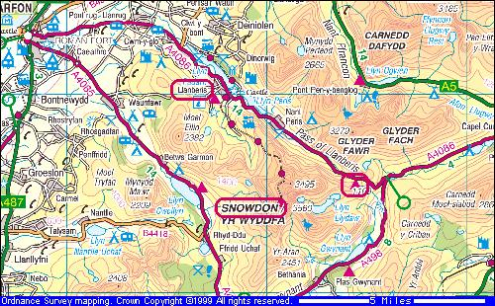

Driving Route & Support Information
The original 'Driving' information page has been moved and is located here. However, due to the constant roadworks, traffic diversions, updates and alterations, we now have moved information onto the forum which is updated weekly during the summer months. We also have route and satnav information in .pdf format which can easily be printed off. Please direct any questions to the forum, rather than email.
Your ideal route choice will depend upon the size and type of vehicle, day and time of start of your challenge, challenge direction, and choice of Wasdale or Seathwaite for Scafell Pike. Access to Wasdale Head is very narrow, and is totally unsuitable for coaches.
On an average challenge, you can expect to be driving some 450 miles over 10 or 11 hours including some comfort/fuel stops, and there are many police safety cameras on the route - so do not be tempted to make up lost time by speeding. You will also need to drive to the start of the challenge, and drive home afterwards.
With years of Three Peaks Challenge experience, please accept our following safety advice for an enjoyable challenge:
1. DO NOT try to drive and walk. Get at least one, preferably two, dedicated drivers who will not be climbing the mountains. NEWS
2. Take a 20 minute break between Ben Nevis and Scafell Pike. This should be used to sort kit, freshen up, get fuel, get hot food/drinks.
3. Sort food and drinks for both walkers and drivers. Allow drivers to get plentry of rest/sleep whilst you are walking the mountains.
4. Get up-to-date route information via our forum..!
Remember that after each mountain you will need to get changed, have a hot or cold drink, and get some food. If you have a dedicated driver or two, they can act as your support team and prepare some hot food and drinks for you. Let them know when you are about to return, using mobile phones or VHF radios if possible.

Driving notes and routes
One of the hardest parts of the challenge is driving between the hills. This alone will clock up some 500 miles, and take around 10 hours. Remember that you will have to drive to the start of the challenge, and then, of course, drive home afterwards. So your round trip will be at least 1,000 miles, but realisticaly a lot further unless you live on the route.

Other things that need to be done whilst travelling:

Eating
Drinking
Changing wet clothes
Top up water bottles
Replace used items
Change maps and route cards
Navigate
Get Fuel
Toilet stop
Sleep !!!
For this reason, a dedicated pair of drivers would be invaluable to share the driving and navigation. If this isn't possible, you will have to take it in turns to drive and navigate, whilst the others sort themselves out and get some rest.
Remember that the more tired a driver becomes, the chances of them driving unsafely, getting lost, taking chances or falling asleep increase.

Don't forget to do basic vehicle checks before you leave home, oil, tyre pressures, washer bottle etc, and make sure that the jack and wheelbrace won't be stored underneath everyone's kit. Sort out a light for the navigator which won't annoy the driver during darkness. Try to fuel up before the start, will the vehicle need fueling en-route? If so, where?
And is the petrol station 24 hour?
Running late?
Speed cameras are in use throughout the country. The last time I drove to Scotland I saw three laser speed traps, set up from ordinary unmarked Police cars, above the motorways on a bridge. If you are speeding - by the time you see these traps you will have been caught.
It is quite possible to be banned from driving during a single challenge attempt, and you won't find out until a few weeks later....

Many challenge organisers now impose a minimum driving time of 10 hours, so there really is no reason to speed anyway.
Route details

From Fort William
A82 south to Crianlarich
A85 south to M9
Stirling Services
Join M80 to J4
A80 to M73
Join M74 south
Bothwell Services
M74 to J44 M6
A7 to Carlisle
A595 to Gosforth
At Gosforth, minor road
to Wasdale Head
Minor roads back to A595
A595 south toward Barrow
A5092 to Lowick
A590 to Newby Bridge
A591 to M6
M6 south
Forton Services
Charnock Richard Services
Join M56 after J20
M53 south into A55
A55 toward Bangor
A5 south for 100metres
B4366 to roundabout
B4547 to T junction
Left into A4086 to Llanberis.
Continue for Pen-y-Pass.
These route details are subject to change as roads are improved etc. Check the route on an up-to-date road map before starting.
Checking Teletext for any travel info will help you decide on the best route for you to use.
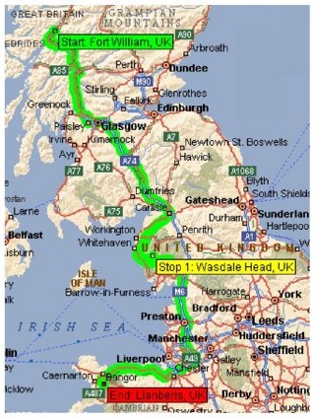
Remember to check for roadworks or other expected delays before you start your challenge, and vary the route accordingly.

